**B**

angladesh played ICC Cricket World Cup for the first time in the year 1999, when it came in one of the three ICC Trophy Qualifiers (the other two being Kenya and Scotland). By the next World Cup, it had become one of the test-playing nations of the world and thus, one of the contenders of the tournament as well.

The team knocked out India in 2007 World Cup. Bangladesh also knocked out England in 2015 World Cup but facing defeat against India in Quarter final.

**3. In the Same Document Write these Symbols**

💣🕱🖭🕾£

**4. In the same document Apply Wordart in the below test**.

**IDB-BISEW IT SCHOLARSHIP**

**5. Insert table and format as below (in the same document)**

|  |  |  |
| --- | --- | --- |
|  |  |  |
|  |  |  |
|  |  |  |

**6. Make a chart format as below test.**

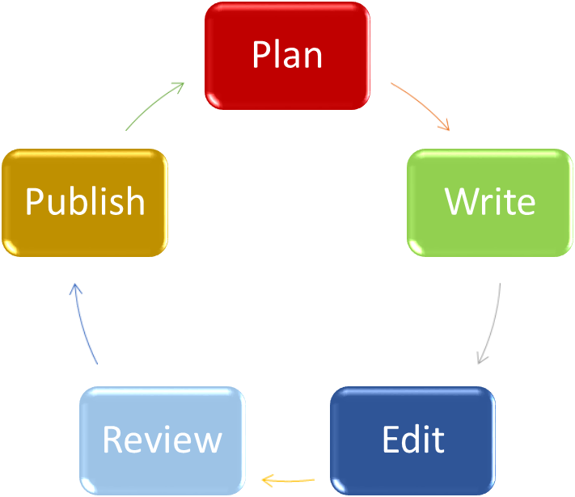

7. Write down these words:

1. H2SO4
2. ©

8.